- Product Overview: -
The WIN-SN-TNH-LUX-M-(OD) is an industrial-grade outdoor environmental monitoring sensor designed for accurate measurement of Temperature, Relative Humidity, and Ambient Light Intensity (Lux). The device combines multiple sensing parameters in a single compact unit and communicates through an RS485 interface using the industry-standard Modbus RTU protocol.
The integrated lux sensor provides a measurement range of 0 to 200,000 Lux, enabling precise monitoring of ambient lighting conditions in both indoor and outdoor environments. Along with temperature and humidity measurements, the sensor delivers real-time data for environmental monitoring, automation, and smart infrastructure applications.
The WIN-SN-TNH-LUX-M-(OD) supports user-configurable communication settings, including Modbus Slave ID, Baud Rate, Parity, and Stop Bit configuration, allowing seamless integration with PLCs, SCADA systems, IoT gateways, data loggers, and Building Management Systems (BMS).
Designed for reliable outdoor operation, the sensor features a robust enclosure and stable performance, making it suitable for weather monitoring stations, smart city deployments, greenhouses, industrial automation, building management systems, agricultural applications, and environmental monitoring projects.
- Key Features
- Measures Temperature, Relative Humidity, and Ambient Light Intensity (Lux).
- Lux measurement range from 0 to 200,000 Lux.
- Industrial-grade sensor designed for outdoor environmental monitoring applications.
- RS485 communication interface with Modbus RTU protocol support.
- Real-time monitoring and transmission of environmental data.
- User-configurable communication parameters through software settings.
- Configurable Modbus Slave ID (1 to 247).
- Supports baud rates up to 115200 bps.
- Configurable Parity and Stop Bit settings.
- Factory default settings: 9600 bps, Slave ID 1, Parity 3, Stop Bit 1.
- Built-in factory reset functionality for restoring default communication settings.
- High measurement accuracy and long-term stability.
- Fast response time for environmental monitoring applications.
- Supports multi-drop RS485 network architecture.
- Easy integration with PLCs, SCADA systems, HMIs, IoT gateways, and data loggers.
- Robust outdoor enclosure for reliable field deployment.
- Low maintenance and long operational life.


- Suitable for smart cities, weather stations, agriculture, greenhouses, industrial automation, and building management systems.
Certifications:

Sensor Specification:-

Measuring Parameter | Measuring Range | Accuracy
Temperature | -40 °C to +120 °C | ±0.3 °C
Humidity | 0 ~ 100 % RH | ±2 % RH
Lux | 0 ~ 200,000 lux | -

- Technical Specifications
- Operating Voltage: 12-24v DC
- Interface: Modbus RS485
- Function Code: 0x03
- Product dimension (D X H) : 140 X 200 mmZ

- Communication and Configuration Settings:-

The WIN-SN-TNH-LUX-M-(OD) communicates using the RS485 interface with the Modbus RTU protocol. The device is factory-configured with a Baud Rate of 9600 bps, Slave ID 1, Parity setting 3, and 1 Stop Bit, allowing quick deployment in standard Modbus networks.
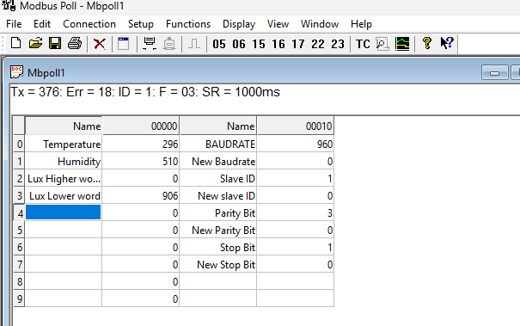

To support a wide range of industrial applications, communication parameters can be modified through software settings. Users can configure the Baud Rate up to 115200 bps, assign a Modbus Slave ID from 1 to 247, and adjust the Parity and Stop Bit settings according to system requirements. These configurable parameters provide flexibility for integration with PLCs, SCADA systems, IoT gateways, HMIs, and other Modbus-compatible devices.
Example screenshots illustrating the software configuration procedure are provided below for reference.

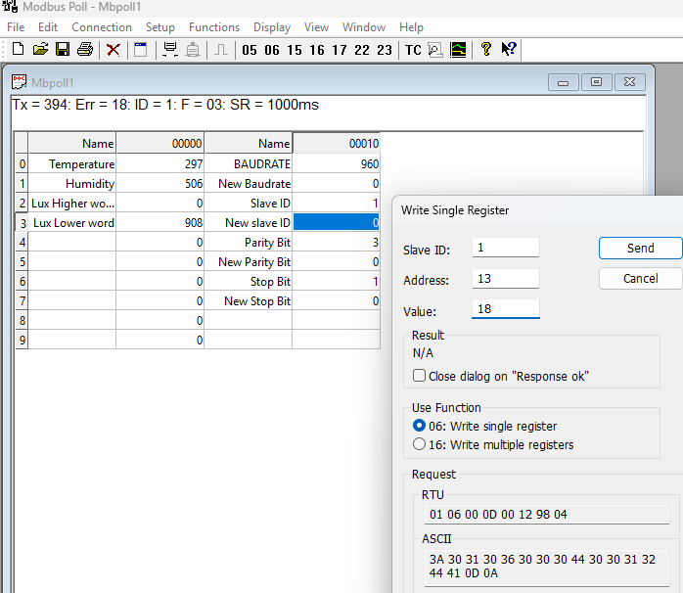

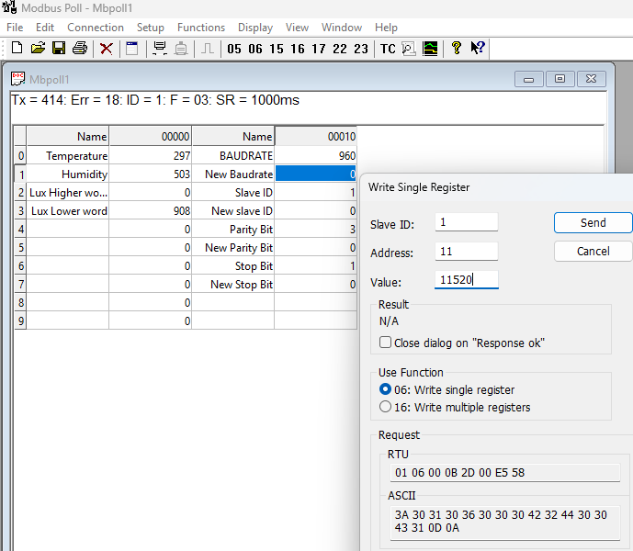

Factory Reset: -
The device includes a factory reset feature that restores all communication parameters to their default settings. To perform a factory reset, place the configuration jumper in the Factory Reset position and press and hold the Reset button for approximately 5 seconds. The device will automatically restart and restore the factory default communication settings:
- Baud Rate: 9600 bps
- Slave ID: 1
- Parity: 3
- Stop Bit: 1
This feature allows users to quickly recover communication with the device if the configured settings are unknown or incorrectly configured.

- Modbus Register Values :-
ID | Function Description | Register Description | Modbus Function  Code | Protocol | Data Type
1 | Temperature | 40000 | 0x03 | RS485 | 16-bit int
2 | Humidity | 40001 | 0x03 | RS485 | 16-bit int
3 | Lux Higher Word | 40002 | 0x03 | RS485 | 16-bit int
4 | Lux Lower Word | 40003 | 0xo3 | RS485 | 16-bit int

Note: - Values upto 65k Lux will be populated in 4003 register and higher values will
Available in 4002 register.
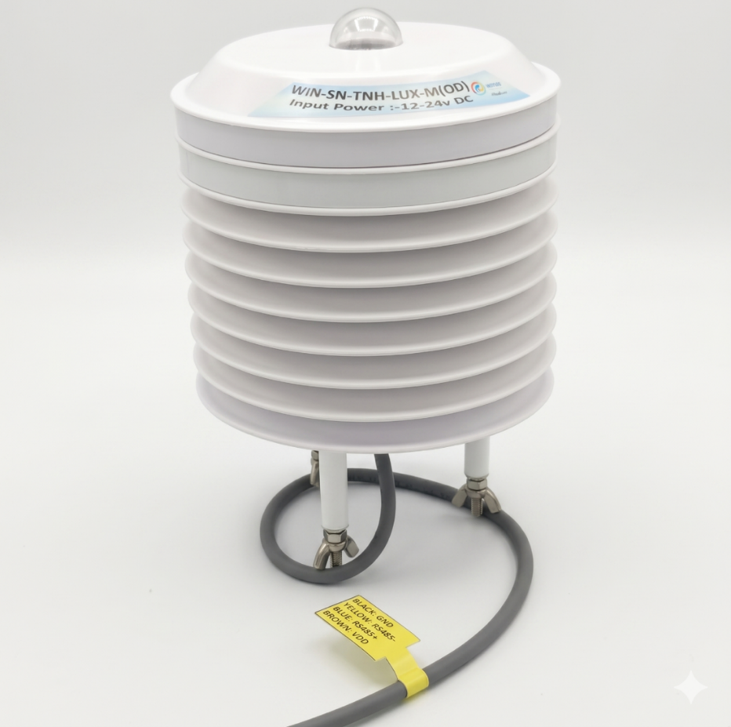

Note: Base plate will be supplied for easy mounting on Pole etc.

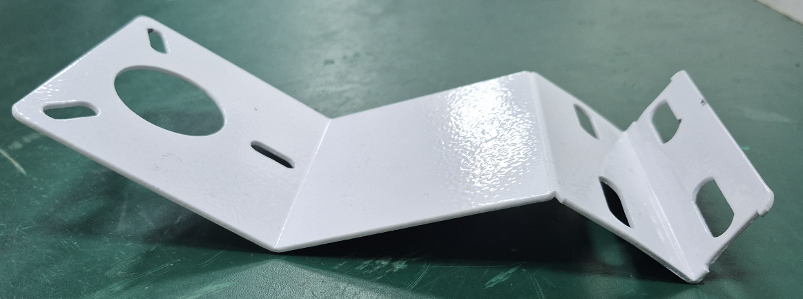

Contact Information
Augmatic Technologies Pvt. Ltd.,
Plot no 6, Shah Industrial Estate II,
Kotambi,
Vadodara – 391510.
Email – Sales@wittelb.com
Support E.: support@wittelb.raiseaticket.com / M.: 9403892805

